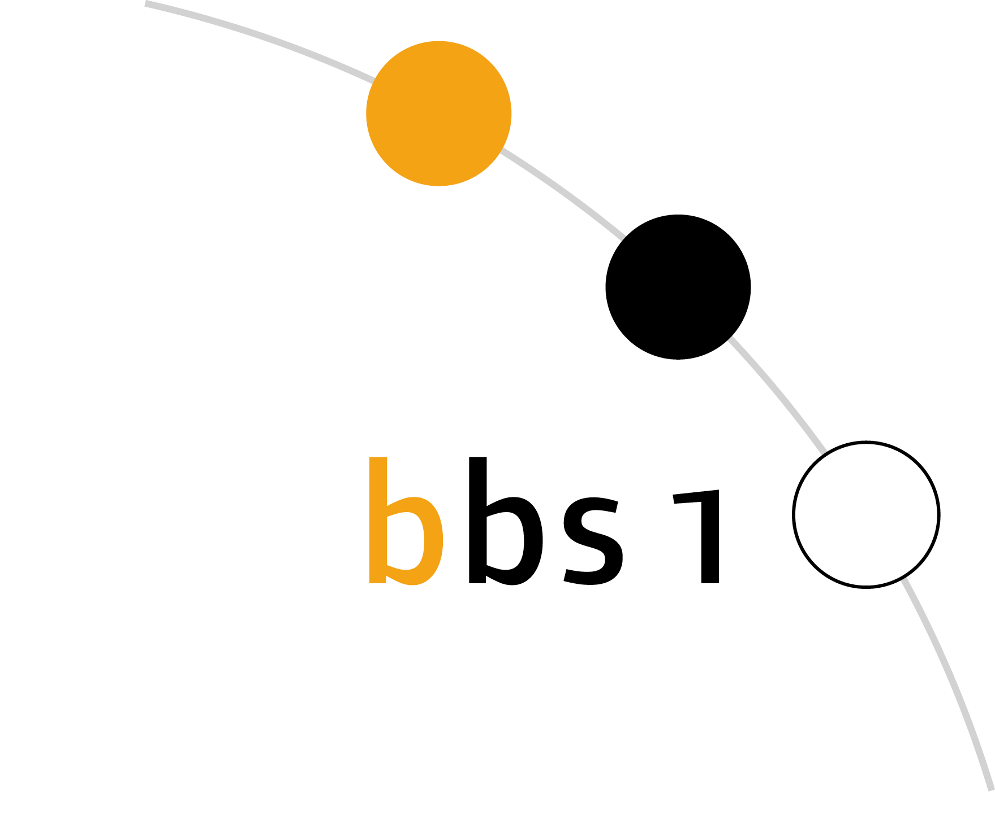

Please add passport photo

Please pay attention:
In this course, we can only accept minors aged 15 to 17 with legal residence in Mainz!

Berufsbildende Schule 1

Gewerbe und Technik

Am Judensand 12
55122 Mainz
Fon 06131 90 60 30
Fax 06131 90 60 3-99
sekretariat@bbs1-mainz.de www.bbs1-mainz.de

Application form

Berufsvorbereitungsjahr Sprachförderung/
Preparatory course with introduction to German language and culture

Please fill in the form in block letters!

Last name |  |  |  |  | In care and custody of:
First name |  |  |  |  | father q mother q other q
sex | male  female  |  | Date of birth |  | Last name
Place of birth |  |  | Country of birth |  | First name
Nationality |  |  | Mother tongue |  | Street
Moving in from (country) |  |  | Moving in (date) |  | Postcode
Religion |  | Marital Status |  |  | City
Street |  |  |  |  | Phone
Postcode and city |  |  |  |  | Fax
Phone |  |  | Fax |  | Cell phone
Cell phone |  |  |  |  | E-mail
E-mail
Disabilities/illnesses (if relevant for school)

To complete your application we need:
- a CV
- an official document providing information about residence and correct writing of name
- a passport photo

Information about schooling before coming to Germany:

Years of formal schooling:  Certificates acquired: | Country/countries of schooling:  Language of schooling: | Languages spoken:  Career aspirations:

Place ......................................................., Date ......................................................…...

............................................................... .................................................................
Signature pupil Signature person having care and custody

--------- To be filled in by school ------
Zuteilung zu BBS:
 | Mainz, den | i.A. Katja Zimmermann, StD‘

